**EASTERN RAILWAY**

**STATION MASTER PORTAL**

**A SUMMER TRAINING REPORT**

*Submitted by*

**Rupam Ganguly**

University Roll Number: GCECTB-L17-2006

University Reg. Number: 171130120013 OF 2017-18

*In partial fulfillment of Summer Training for the award of the degree*

*of*

BACHELOR OF TECHNOLOGY

IN

**INFORMATION TECHNOLOGY**

**Govt. College of Engineering & Ceramic Technology**

73, Abinash Chandra Banerjee Ln, Subhas Sarobar Park,

Phool Bagan, Beleghata, Kolkata, West Bengal 700010

JUNE-JULY 2019

**ABOUT THE PROJECT**

The Eastern Railway is among the 18 zones of the Indian Railways. It has 579 stations spread across its 4 divisions, viz. , Howrah, Sealdah, Malda, Asansol.

Each Railway Station in Eastern Railway is managed by a Station Manager or a Station Master. For the purpose of his knowledge & to apprise general public or passenger he needs information about various facilities or amenities available in each station. The information should be presented in an organized manner which can be viewed by the station master and is required to be updated, as and when necessary.

The project “EASTERN RAILWAY STATION MASTER PORTAL” is conceived to provide a portal, developed with an objective to enable a single window access to information and services being provided in each station by the Eastern Railway. The content in the portal can be viewed or updated by the station master through an Admin login.

**ABOUT THE COMPANY-EASTERN RAILWAY**

The East Indian Railway (EIR) Company was incorporated in 1845 to connect East India with Delhi.

Eastern Railway was formed on 14th April, 1952 by integration of the East Indian Railway consisting of Sealdah, Howrah, Asansol and Danapur Divisions and the entire Bengal Nagpur Railway. Later on, the portion of BNR stretching from Howrah to Visakhapatnam in the South.

After the Government of India took over the management of EIR in 1925, it was splitted into six divisions — Howrah, Asansol and Dinapore known as the lower divisions and Allahabad, Lucknow and Moradabad known as the upper divisions.

The **Eastern Railway** is among the 18 zones of the [Indian Railways](https://en.wikipedia.org/wiki/Indian_Railways). Its headquarters is at Fairley Place, [Kolkata](https://en.wikipedia.org/wiki/Kolkata) and comprises four divisions: [Howrah](https://en.wikipedia.org/wiki/Howrah), [Malda](https://en.wikipedia.org/wiki/English_Bazar" \o "English Bazar), [Sealdah](https://en.wikipedia.org/wiki/Sealdah" \o "Sealdah), and [Asansol](https://en.wikipedia.org/wiki/Asansol" \o "Asansol). Each division is headed by a Divisional Railway Manager (DRM). The name of the division denotes the name of the city where the divisional headquarters is located. On 1 October 2002 a new zone, the East Central Railway, headquarters at Hajipur, was carved out by separating the Eastern Railway's Danapur, Dhanbad and Mughalsarai divisions from it.

Later, the portions of BNR stretching from Howrah to Visakhapatnam in the South, Howrah to Nagpur in the Central area and upto Katni in the North Central Region were separated from Eastern Railway and formed as “South Eastern Railway” with effect from 1st August 1955.

Asansol Division was formed in 1925, Dhanbad Division in 1964, Mughulsarai Division in 1975 and Malda Division in 1984 as part of ER.

After redistribution and construction of new lines over a period of time, Eastern Railway as on 30th September 2002, stretched over 4245.61 kilometres.

On 01-10-2002, three divisions viz. Dhanbad, Mughal Sarai and Danapur were separated from Eastern Railway to create new *East Central Railway* zone with headquarters at Hajipur. Eastern Railway now consists of 2500 Route Kilometres spread over **four divisions** viz. **Sealdah**, **Howrah**, **Asansol** and **Malda** out of which 1424 route kilometres are electrified on 25 KV AC traction.

**ACKNOWLEDGEMENT**

The success and final outcome of this project required a lot of guidance and assistance from many people and I am extremely privileged to have got this all along the completion of my project. All that I have done is only due to such supervision and assistance and I would not forget to thank them.

  I respect and thank the Senior System Manager/IT Mr. Suman Maitra of Information Technology Centre /HQ/Eastern Railway, for providing us the opportunity to do the project work at IT Centre/HQ and giving us all the support which helped us in completing the project duly.

I owe my deep gratitude to our project guide **Mr. Sujit Das (SE/IT)**, **Mr. Rakesh Kumar Meena (SE/IT)** and **Mr. Anup Lal Das (JE/IT)**, who took keen interest on our project work and guided us all along, till the completion of our project work by providing all the necessary information for developing a good system.

I would not forget to remember **Mr. Sujit Das** of **EASTERN RAILWAY** for his encouragement and more over for his timely support and guidance till the completion of our project work.

I heartily thank my parents without whom I wouldn’t even get the chance to get trained from this esteemed company.

I am thankful to and fortunate enough to get constant encouragement, support and guidance from all Teaching staffs of **IT Centre** which helped us in successfully completing our project work. Also, I would like to extend our sincere esteems to all staff in laboratory for their timely support.

**Name: Rupam Ganguly**

**DATA FLOW DIAGRAM**

**Level 0**

Eastern

Railway Station

Master Portal

Login

Generate

User

Reports

**Level 1**

User

Login

Verification

Yes

Station Master Portal

**ABSTRACT**

Building a web interface with the help of HTML/CSS for front-end designing, PHP for back-end scripting and MySQL for connecting with database and managing it.

The goal of this application is to create the foundation for a web-based record keeping system for the number of stations and their respective information, existing within a particular division of Eastern Railway and managing those information efficiently.

We have coded the web pages as it appears in the browser with the help of HTML and styling of the web page is done with the help of CSS. Further we have made use of the pre- built library - “bootstrap.css” which is open source and readily available online for styling web pages.

The back-end programming for the web pages is implemented with the help of PHP which is the server side scripting language to manipulate and control the flow of data and functions. PHP is also used for security - verification and session tracking.

The database is present on the server computer and data is stored, retrieved and update or deleted from the database with the help of MySQL queries which is operated with the help of an SQL based software that is run at the server computer. Even though SQL queries are used to manipulate the database, but the flow of control is managed with PHP only.

STATION MASTER PORTAL project’s main idea is to implement an offline portal for organization through which users can manage and control information related to stations and information of other facilities at one place. Using this application in any organization can save time and no cost of human resource. This application covers different functionalities like user login, search stations and availability of services, updation, deletion and we can also search for further details required.

It mainly searches the names of the Ministers of Parliaments and Ministers of Legislative Assemblies under every particular station category. These MPs and MLAs can be contacted whenever there is huge discrepancy with the controlling and facilities of any station, it also allows the admin to get a clear idea about the working conditions of each and every station and the areas of development. It’s completely an offline source of information and hence no cost is involved. We can also change the name of MPs and MLAs according to the elections.

As soon as the user logs in to the portal, he gets seven options to perform, which are:

1. HOME - Displays the home screen with all all the seven options and a welcome message with the user’s name.
2. SEARCH - Helps in searching any station and its division.
3. ADD – Adds new station along with its details, it’s categories and facilities provided
4. UPDATE – Updates necessary changes when necessary such as, name of any MPs or MLAs or any additional facilities provided to a station after renovation.
5. DELETE – If any mistakes have been performed then, this option helps in deleting those information or sometimes name and details of an entire station if it has become obsolete and non-functional.
6. REPORTS - Generates reports based on certain criteria and gives results showing the station name and category.
7. LOGOUT – After successful completion of the entire process the user can logout of the portal.

**TABLE OF CONTENTS**

|  |  |  |
| --- | --- | --- |
| SL. NO | TOPIC | PAGE NUMBER |
| 1 | About the project |  |
| 2 | About the Company-Eastern Railway |  |
| 3 | Acknowledgement |  |
| 4 | Data Flow Diagram |  |
| 5 | Abstract |  |
| 6 | List of Tables |  |
| 7 | List of Figures |  |
| 8 | List of Photographs |  |
| 9 | Introduction |  |
| 10 | Theory |  |
| 11 | Problem Statement And Solution |  |
| 12 | Methodology Adopted |  |
| 13 | Results and Discussions |  |
| 14 | Conclusion and Future Scope of Study |  |
| 15 | References |  |
| 16 | Appendices |  |

**LIST OF TABLES**

* **Database** used for the project – station_master

Table 1- **stations**

| **Sl.No.** | **Field** | **Type** | **Null** | **Key** | **Default** | **Extra** |
| --- | --- | --- | --- | --- | --- | --- |
| 1 | station_id | int(11) | NO | PRI | *NULL* | auto_increment |
| 2 | station_code | varchar(10) | NO |  | *NULL* |  |
| 3 | Station_name | varchar(150) | NO |  | *NULL* |  |
| 4 | Station_category | varchar(10) | NO |  | *NULL* |  |
| 5 | Division_code | varchar(10) | NO |  | *NULL* |  |
| 6 | Division_name | varchar(150) | NO |  | *NULL* |  |
| 7 | State_code | varchar(10) | NO |  | *NULL* |  |
| 8 | State_name | varchar(100) | NO |  | *NULL* |  |
| 9 | name_mp | varchar(150) | NO |  | *NULL* |  |
| 10 | constituency_mp | varchar(100) | NO |  | *NULL* |  |
| 11 | party_code_mp | varchar(10) | NO |  | *NULL* |  |
| 12 | party_name_mp | varchar(100) | NO |  | *NULL* |  |
| 13 | name_mla | varchar(150) | NO |  | *NULL* |  |
| 14 | constituency_mla | varchar(100) | NO |  | *NULL* |  |
| 15 | party_code_mla | varchar(10) | NO |  | *NULL* |  |
| 16 | party_name_mla | varchar(100) | NO |  | *NULL* |  |
| 17 | is_active | enum('y','n') | NO |  | *NULL* |  |
| 18 | active_year | varchar(10) | NO |  | *NULL* |  |
| 19 | remarks | varchar(100) | YES |  | *NULL* |  |
| 20 | created_by | varchar(10) | NO |  | *NULL* |  |
| 21 | created_on | datetime | NO |  | current_timestamp() |  |
| 22 | fob | enum('y','n') | NO |  | *NULL* |  |
| 23 | rr | enum('y','n') | NO |  | *NULL* |  |
| 24 | divyang | enum('y','n') | NO |  | *NULL* |  |
| 25 | hlp | enum('y','n') | NO |  | *NULL* |  |
| 26 | trolley | enum('y','n') | NO |  | *NULL* |  |
| 27 | wh | enum('y','n') | NO |  | *NULL* |  |
| 28 | ps | enum('y','n') | NO |  | *NULL* |  |
| 29 | lifts | enum('y','n') | NO |  | *NULL* |  |
| 30 | escalator | enum('y','n') | NO |  | *NULL* |  |
| 31 | dcd | enum('y','n') | NO |  | *NULL* |  |
| 32 | illumination | enum('y','n') | NO |  | *NULL* |  |
| 33 | indication | enum('y','n') | NO |  | *NULL* |  |

Table 2 **– users**

| **Sl. No.** | **Field** | **Type** | **Default** | **Key** | **Extra** |
| --- | --- | --- | --- | --- | --- |
| 1 | **user_idPrimary** | int(11) | Null | PRI | *None* |
| 2 | **username** | varchar(100) | Null |  | *None* |
| 3 | **password** | varchar(100) | Null |  | *None* |
| 4 | **is_active** | enum('y', 'n') | Null |  |  |

**LIST OF FIGURES**

Table 1 – ‘**stations**’ 15 records and 7 fields

|  |  |  |  |  |  |  |
| --- | --- | --- | --- | --- | --- | --- |
| **Sl. No.** | **Station ID** | **Station Name** | **Station Code** | **Station Category** | **Division** | **State** |
| 1 | 21 | Asansol | ASN | NSG-2 | Asansol | West Bengal |
| 2 | 49 | Ballygunge | BLN | SG-3 | Sealdah | West Bengal |
| 3 | 71 | Barrackpur | BP | SG-2 | Sealdah | West Bengal |
| 4 | 81 | BBD Bag | BBDB | SG-3 | Sealdah | West Bengal |
| 5 | 98 | Bhagalpur | BGP | NSG-1 | Malda | Bihar |
| 6 | 124 | Budge Budge | BGB | SG-3 | Sealdah | West Bengal |
| 7 | 154 | Dankuni | DKAE | SG-3 | Howrah | West Bengal |
| 8 | 179 | Dumdum Jn | DDJ | SG-2 | Sealdah | West Bengal |
| 9 | 183 | Durgapur | DGR | NSG-3 | Asansol | West Bengal |
| 10 | 235 | Hooghly | HGY | SG-3 | Howrah | West Bengal |
| 11 | 238 | Howrah | HWH | NSG-1 | Howrah | West Bengal |
| 12 | 255 | Jasidih | JSME | NSG-3 | Asansol | Jharkhand |
| 13 | 370 | Majherhat | MJT | SG-3 | Sealdah | West Bengal |
| 14 | 372 | Malda Town | MLDT | NSG-3 | Malda | West Bengal |
| 15 | 515 | Sealdah | SDAH | NSG-1 | Sealdah | West Bengal |

Table 2 – ‘**users**’ 5 records 4 fields

|  |  |  |  |
| --- | --- | --- | --- |
| **user id** | **username** | **password** | **is active** |
| 1 | rupam | rupam | y |
| 2 | urmi | urmi | y |
| 3 | admin | admin | y |
| 4 | dipen | dipen | y |
| 5 | oishee | oishee | y |

**LIST OF PHOTOGRAPHS**

**Login Page**:

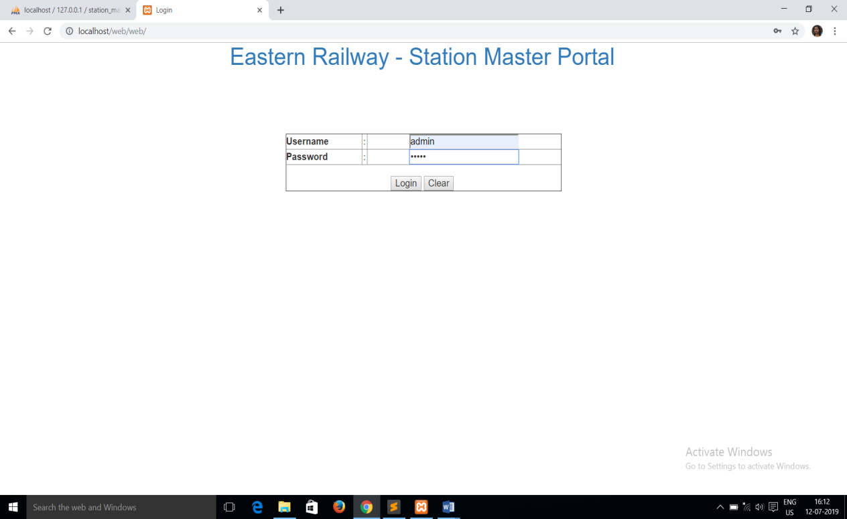

**Home Page (after successful log in):**

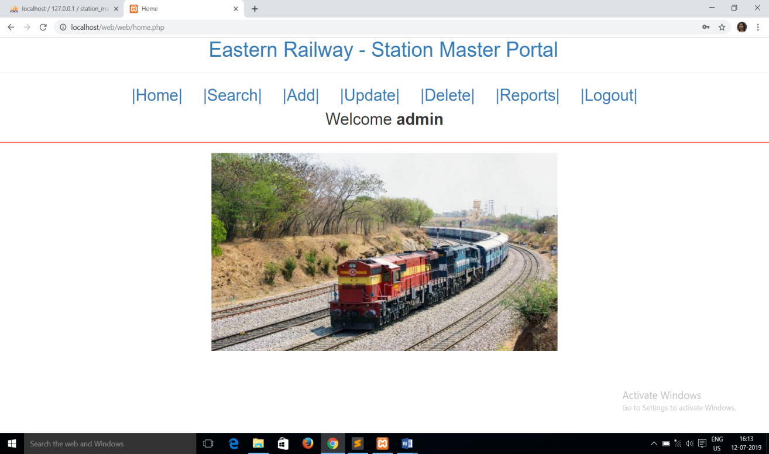

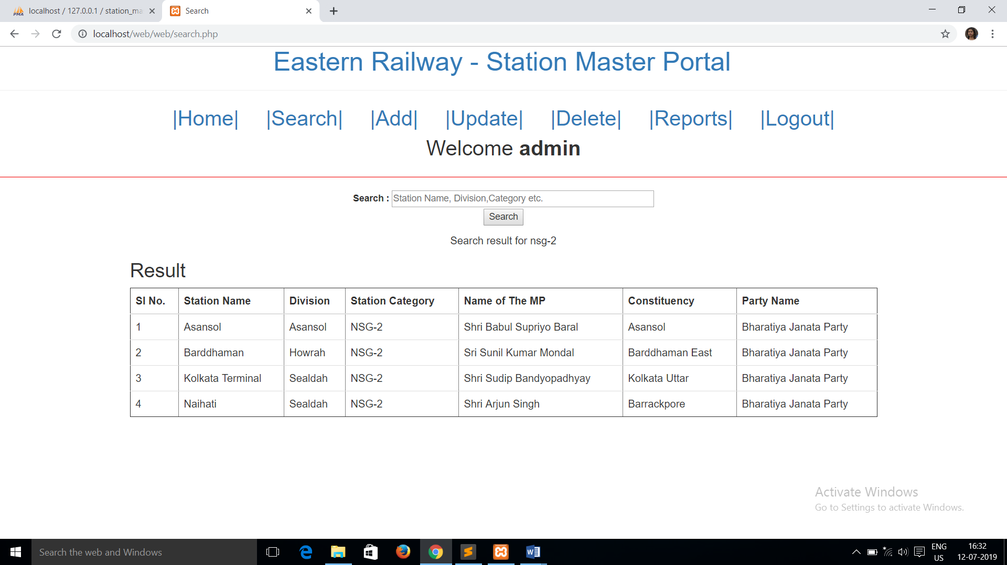

**Search Result for Dum:**

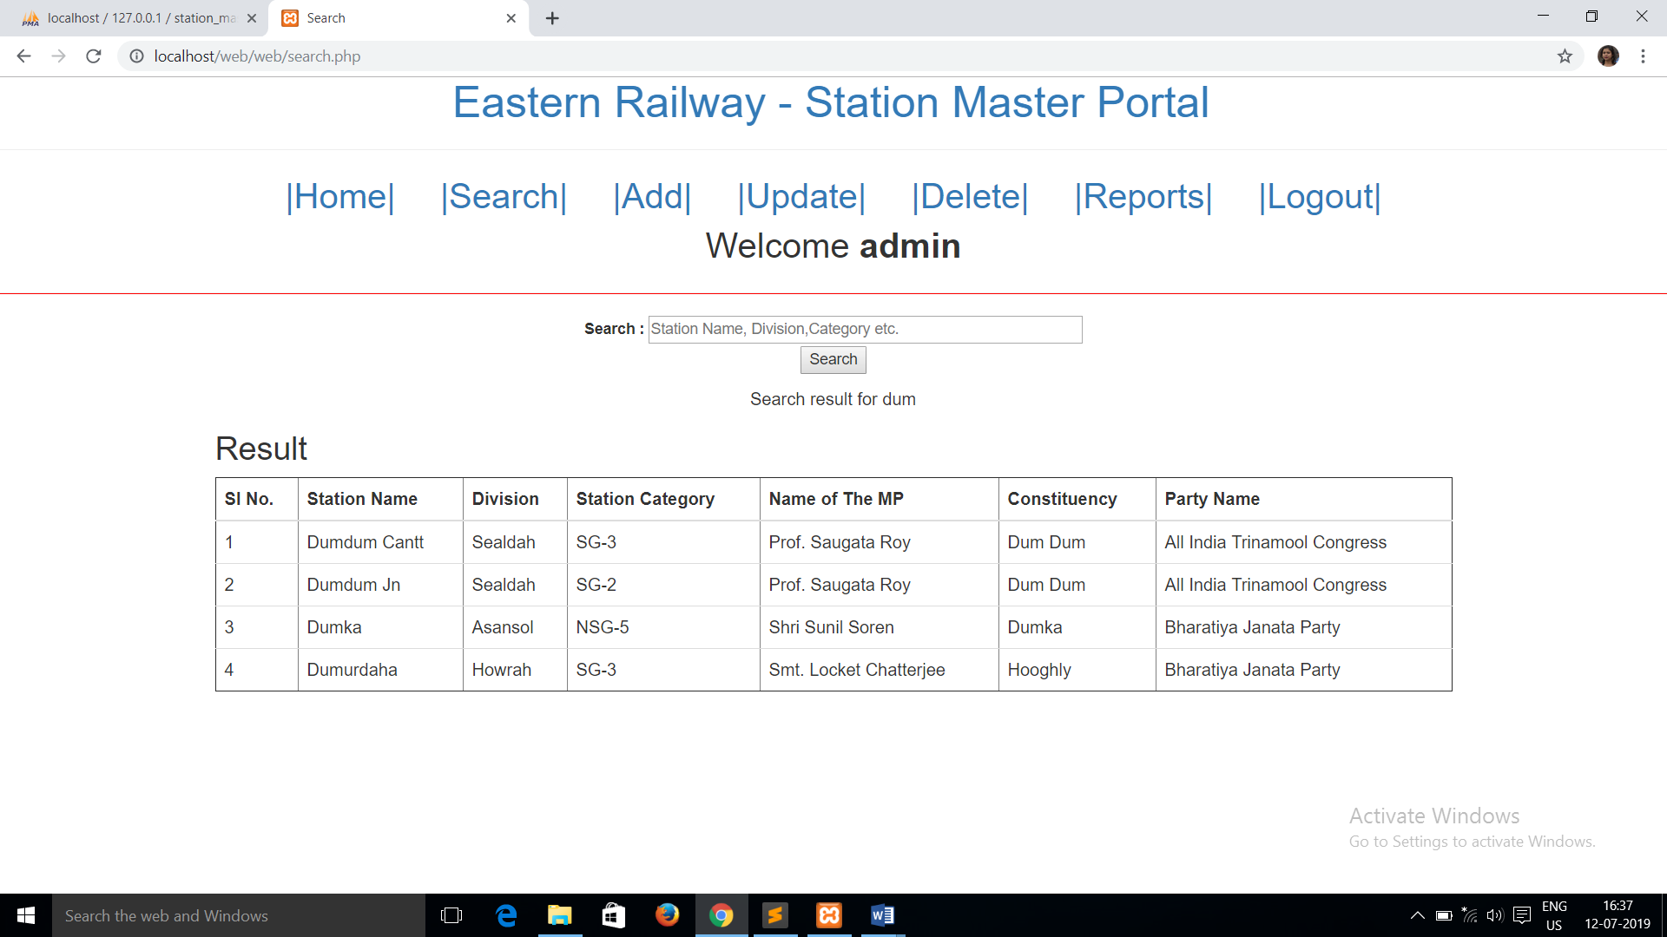

**To Add a new station(filling up all the fields):**

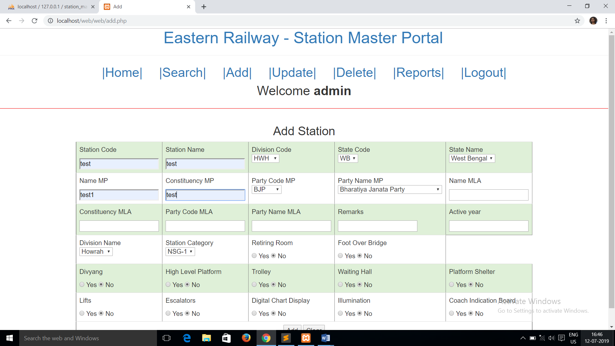

**When the new station is added successfully:**

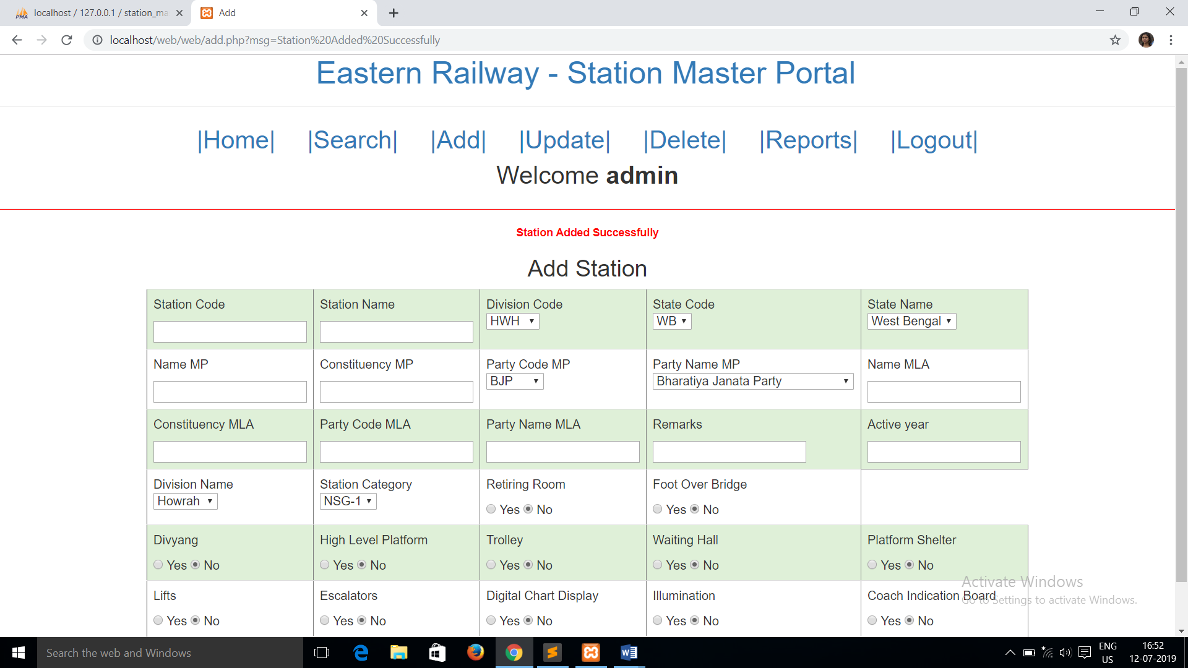

**To check in search whether the ‘test’ station is added successfully or not:**

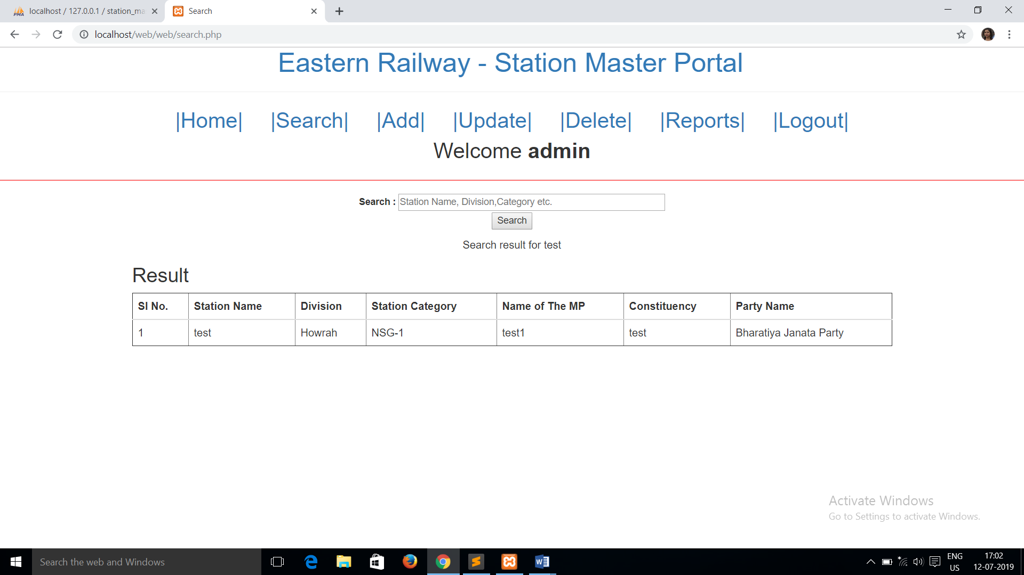

**To Update station any station(here ‘test’, which is user input):**

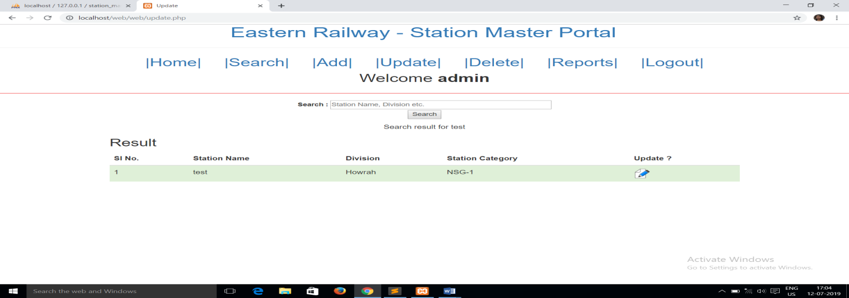

**Update confirmation:**

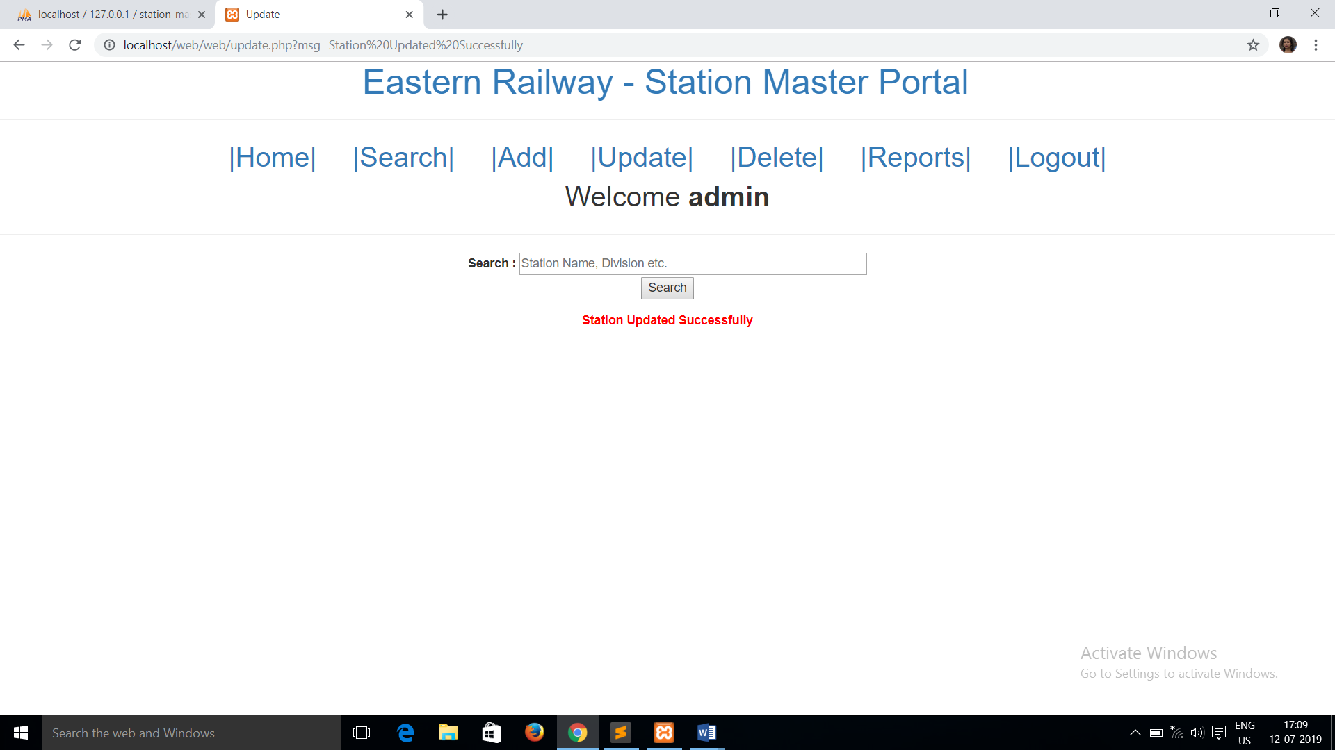

**Search for delete (here ‘test’):**

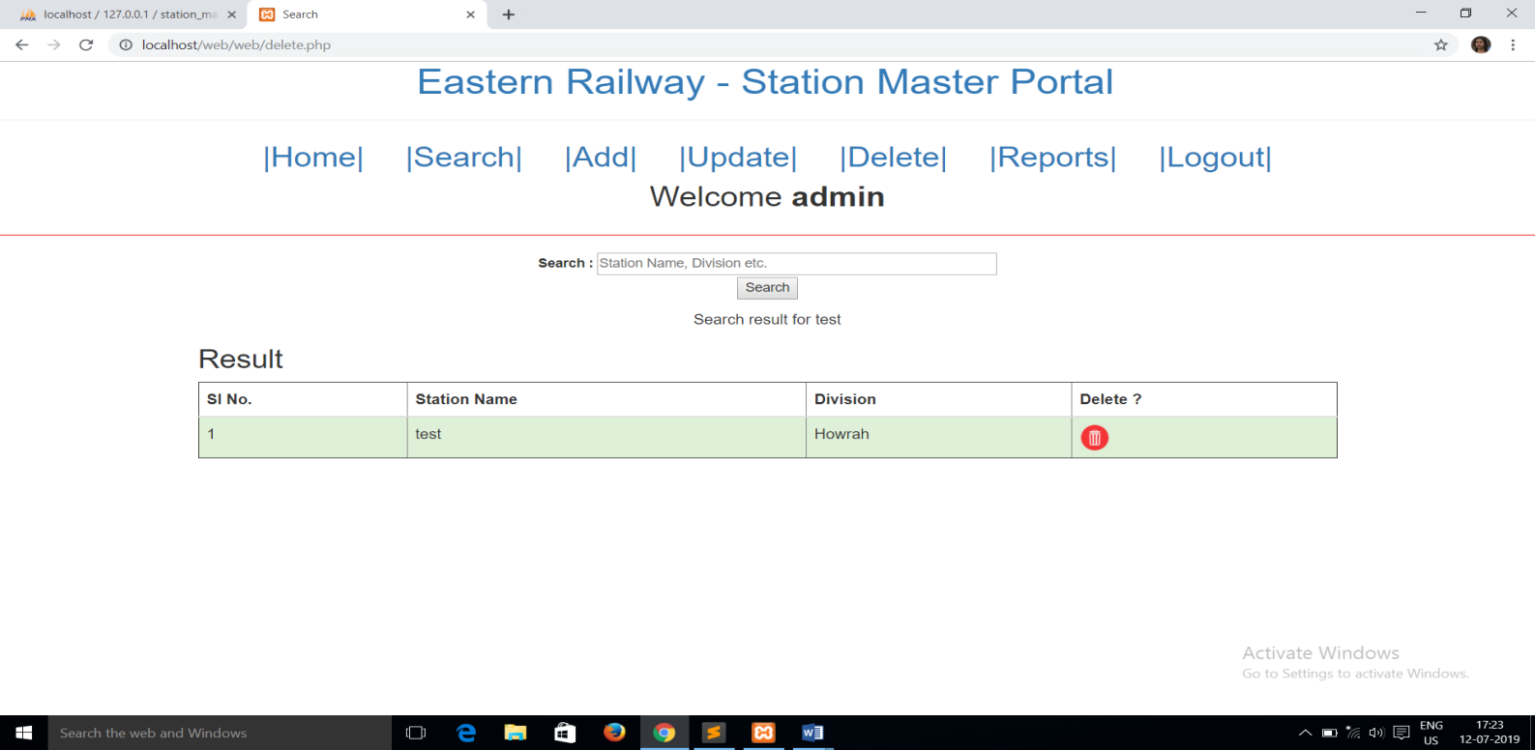

**Deleted Successfully**:

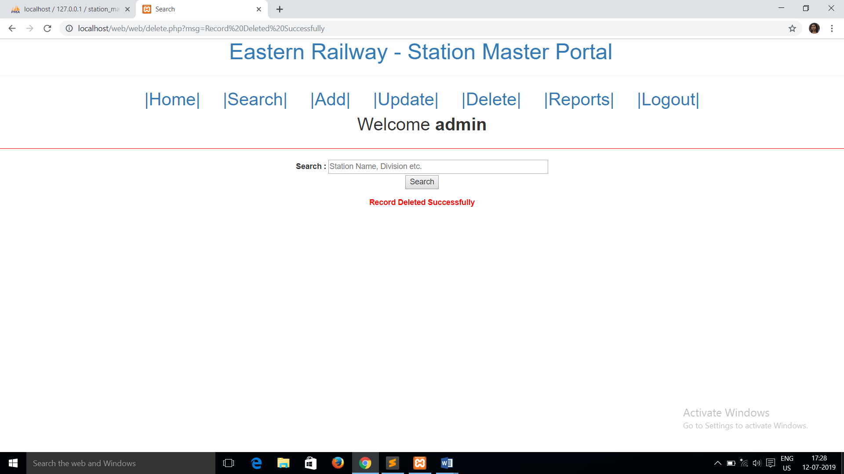

**INTRODUCTION**

This project’s aim is to give us information about all the different categories of railway stations present within the Eastern Railway zone which is divided into four major divisions namely - HOWRAH, MALDA, SEALDAH and ASANSOL.

This system is basically concerned with the management and manipulation of data pertaining to different stations present within different categories and divisions.

To be more specific, there are basically 4 tasks that are undertaken within this project.

These tasks are as follows:-

* Function for Addition or Insertion of data within the database. This is administrative privilege which can only be accessed by the admin.
* Function to Search for data according to certain keywords from the database.
* Function to Update data about a particular station in the database.
* Function to Delete data from the database with the help of Primary Key.
* Function to generate Report based on different categories and sub-categories and function to print those tables.

There are certain additional tasks which need to be taken care of while we are performing these basic tasks. These tasks are as follows:-

* Function for Login, and username & password verification.
* Function for Logging Out by destroying all global variables and redirecting to index page.
* Function for session tracking and destroying session variable when the web page is closed.

**THEORY**

Facilities/Systems trained on –

### XAMPP

XAMPP stands for Cross-Platform (X), Apache (A), MariaDB (M), PHP (P) and Perl (P).XAMPP is a [free and open source](https://en.wikipedia.org/wiki/Free_software) [cross-platform](https://en.wikipedia.org/wiki/Cross-platform) [web server](https://en.wikipedia.org/wiki/Web_server) [solution stack](https://en.wikipedia.org/wiki/Solution_stack) package developed by Apache Friends.

-> The Apache HTTP Server, colloquially called Apache, is the world's most used web server software.

-> [MariaDB](https://en.wikipedia.org/wiki/MariaDB) [database](https://en.wikipedia.org/wiki/Database)-MariaDB is a community-developed fork of the MySQL relational database management system intended to remain free under the GNU GPL.It's made by the original developers of MySQL and guaranteed to stay open source. Notable users include Wikipedia, [WordPress.com: Create a website or blog](http://wordpress.com/)and Google.

-> There are [interpreters](https://en.wikipedia.org/wiki/Interpreter_(computing)) for scripts written in the [PHP](https://en.wikipedia.org/wiki/PHP) and [Perl](https://en.wikipedia.org/wiki/Perl) [programming languages.](https://en.wikipedia.org/wiki/Programming_language)

It is a simple, lightweight Apache distribution that makes it extremely easy for developers to create a local web server for testing and deployment purposes. Everything needed to set up a web server – server application (Apache), database (MariaDB), and scripting language (PHP) – is included in an extractable file.

Alternatives –

* + WAMP

Acronym for Windows/Apache/MySQL/PHP, Python, (and/or) PERL

The acronym WAMP refers to a set of free ([open source](https://www.webopedia.com/TERM/O/open_source.html)) [applications,](https://www.webopedia.com/TERM/A/application.html) combined with Microsoft Windows, which are commonly used in [Web server](https://www.webopedia.com/TERM/W/Web_server.html) environments.

* + EasyPHP

EasyPHP is a complete software package allowing to use all the power and the flexibility that offers the dynamic language PHP and the effecient use of databases. Package includes an Apache server, a MySQL database, a fully PHP execution, as well as easy development tools for your web site or your applications.

### MySQLDatabase

MySQL is a fast, easy-to-use RDBMS being used for many small and big businesses. MySQL is developed, marketed and supported by MySQL AB, which is a Swedish company. MySQL is becoming so popular because of many good reasons −

* MySQL is a very powerful program in its own right. It handles a large subset of the functionality of the most expensive and powerful database packages.
* MySQL uses a standard form of the well-known SQL data language.
* MySQL works very quickly and works well even with large data sets.
* MySQL is very friendly to PHP, the most appreciated language for web development.
* MySQL supports large databases, up to 50 million rows or more in a table. The default file size limit for a table is 4GB, but you can increase this (if your operating system can handle it) to a theoretical limit of 8 million terabytes (TB).
* MySQL is customizable. The open-source GPL license allows programmers to modify the MySQL software to fit their own specific environments.

Alternatives –

* + PostgreSQL

PostgreSQL is a powerful, open source object-relational database system that uses and extends the SQL language combined with many features that safely store and scale the most complicated data workloads.

* + MongoDB

MongoDB is an [open source](https://whatis.techtarget.com/definition/open-source) database management system (DBMS) that uses a document- oriented database model which supports various forms of data. It is one of numerous nonrelational [database](https://searchsqlserver.techtarget.com/definition/database) technologies which arose in the mid-2000s under the [NoSQL](https://searchdatamanagement.techtarget.com/definition/NoSQL-Not-Only-SQL) banner for use in big data applications and other processing jobs involving data that doesn't fit well in a rigid relational model.Instead of using [tables](https://whatis.techtarget.com/definition/table) and [rows](https://searchoracle.techtarget.com/definition/row) as in [relational databases,](https://searchdatamanagement.techtarget.com/definition/relational-database) the MongoDB architecture is made up of collections and documents.

### HTML

HTML was first created by Tim Berners-Lee, Robert Cailliau, and others starting in 1989.

It stands for Hyper Text Markup Language.

Hypertext means that the document contains links that allow the reader to jump to other places in the document or to another document altogether. The latest version is known as [HTML5.](https://html.com/html5/)

A Markup Language is a way that computers speak to each other to control how text is processed and presented. To do this HTML uses two things: tags and attributes.

The definition of HTML is HyperText Markup Language.

* + HyperText is the method by which you move around on the web — by clicking on special text called hyperlinks which bring you to the next page. The fact that it is hyper just means it is not linear — i.e. you can go to any place on the Internet whenever you want by clicking on links — there is no set order to do things in.
  + Markup is what HTML tags do to the text inside them. They mark it as a certain type of text (italicised text, for example).
  + HTML is a Language, as it has code-words and syntax like any other language.

Advantages of HTML:

1. First advantage it is widely used.
2. Every browser supports HTML language.
3. Easy to learn and use.
4. It is by default in every windows so you don't need to purchase extra software.

Disadvantages of HTML:

1. It can create only static and plain pages so if we need dynamic pages then HTML is not useful.
2. Need to write lot of code for making simple webpage.
3. Security features are not good in HTML.
4. If we need to write long code for making a webpage then it produces some complexity.

### 4. CSS

Cascading Style Sheets, fondly referred to as CSS, is a simple design language intended to simplify the process of making web pages presentable.

CSS handles the look and feel part of a web page. Using CSS, you can control the color of the text, the style of fonts, the spacing between paragraphs, how columns are sized and laid out, what background images or colors are used, layout designs,variations in display for different devices and screen sizes as well as a variety of other effects.

Advantages of CSS:

* + CSS saves time − You can write CSS once and then reuse same sheet in multiple HTML pages. You can define a style for each HTML element and apply it to as many Web pages as you want.
  + Pages load faster − If you are using CSS, you do not need to write HTML tag attributes every time. Just write one CSS rule of a tag and apply it to all the occurrences of that tag. So less code means faster download times.
  + Easy maintenance − To make a global change, simply change the style, and all elements in all the web pages will be updated automatically.
  + Superior styles to HTML − CSS has a much wider array of attributes than HTML, so you can give a far better look to your HTML page in comparison to HTML attributes.
  + Global web standards − Now HTML attributes are being deprecated and it is being recommended to use CSS. So its a good idea to start using CSS in all the HTML pages to make them compatible to future browsers.
  + Some of the advantages of using CSS are: Easier to maintain and update.
  + Greater consistency in design.
  + More formatting options.
  + Lightweight code.
  + Faster download times.
  + Search engine optimization benefits.
  + Ease of presenting different styles to different viewers.

### JavaScript

JavaScript is a dynamic computer programming language. It is lightweight and most commonly used as a part of web pages, whose implementations allow client-side script to interact with the user and make dynamic pages. It is an interpreted programming language with object-oriented capabilities.

Advantages of JavaScript

The merits of using JavaScript are −

* Less server interaction − You can validate user input before sending the page off to the server. This saves server traffic, which means less load on your server.
* Immediate feedback to the visitors − They don't have to wait for a page reload to see if they have forgotten to enter something.
* Increased interactivity − You can create interfaces that react when the user hovers over them with a mouse or activates them via the keyboard.
* Richer interfaces − You can use JavaScript to include such items as drag-and-drop components and sliders to give a Rich Interface to your site visitors.

Limitations of JavaScript

We cannot treat JavaScript as a full-fledged programming language. It lacks the following important features −

* Client-side JavaScript does not allow the reading or writing of files. This has been kept for security reason.
* JavaScript cannot be used for networking applications because there is no such support available.
* JavaScript doesn't have any multi-threading or multiprocessor capabilities.

### PHP

PHP started out as a small open source project that evolved as more and more people found out how useful it was. Rasmus Lerdorf unleashed the first version of PHP way back in 1994.

* PHP is a recursive acronym for "PHP: Hypertext Preprocessor".
* PHP is a server side scripting language that is embedded in HTML. It is used to manage dynamic content, databases, session tracking, even build entire e-commerce sites.
* It is integrated with a number of popular databases, including MySQL, PostgreSQL, Oracle, Sybase, Informix, and Microsoft SQL Server.
* PHP supports a large number of major protocols such as POP3, IMAP, and LDAP. PHP4 added support for Java and distributed object architectures (COM and CORBA), making n-tier development a possibility for the first time.
* PHP is forgiving: PHP language tries to be as forgiving as possible.
* PHP Syntax is C-Like.

Common uses of PHP

* PHP can handle forms, i.e. gather data from files, save data to a file, through email you can send data, return data to the user.
* You add, delete, modify elements within your database through PHP.
* Access cookies variables and set cookies.
* Using PHP, you can restrict users to access some pages of your website.
* It can encrypt data.

Five important characteristics make PHP's practical nature possible −

* Simplicity
* Efficiency
* Security
* Flexibility
* Familiarity

# PROBLEM STATEMENT AND SOLUTION

The task or the problem to be undertaken is to maintain a database related to various station present under the jurisdiction of Eastern Railway zone.

We have adopted the following approach to solve this task and present the result in tabular form as fetched from the database.

So different stations are divided according to different Categories and among different Divisions. There are four such divisions according to geographical area and twelve such categories according to number of passengers that come and go within a single working day.

Following are the 4 main divisions under Eastern Railway under which all the stations are grouped together:

* Howrah
* Malda
* Sealdah
* Asansol

The stations have been segregated based on the type and clubbed into 3 groups i.e. non- suburban (NS), suburban (S) and Halt (H). Further these groups have been put in grades ranging from NSG1 - NSG6, SG1 - SG3 and HG1 - HG3 respectively.

Each station is given a unique station id which can be used to identify that particular station uniquely and then accordingly make amendments for that station. So the problem is easily tackled by grouping the station data according to different categories and allocating a unique id for each station to refer and make changes accordingly.

Following are the 12 categories according to which stations are divided while taking into account earnings, passenger footfall, and strategic importance:

|  |  |  |
| --- | --- | --- |
| **Category of stations** | **Criteria of Earnings (in Rs.)** | **Criteria of outward Passengers handled** |
| **I. Non-Suburban** | | |
| **NSG 1** | More than 500 Crore | More than 20 Million |
| **NSG 2** | 100 to 500 Crore | 10 to 20 Million |
| **NSG 3** | 20 to 100 Crore | 05 to 10 Million |
| **NSG 4** | 10 to 20 Crore | 02 to 05 Million |
| **NSG 5** | 01 to 10 Crore | 01 to 02 Million |
| **NSG 6** | Upto 01 Crore | Upto 01 Million |
| **Total of (I)** | | |
| **II. Suburban** | | |
| **SG 1** | More than 25 Crore | More than 30 Million |
| **SG 2** | 10 to 25 Crore | 10 to 30 Million |
| **SG 3** | Upto 10 Crore | Upto 10 Million |
| **Total of (II)** | | |
| **III. Halts** | | |
| **HG 1** | More than 50 Lakh | More than 03 lakh |
| **HG 2** | 05 to 50 lakh | 01 to 03 lakh |
| **HG 3** | Upto 05 lakh | Upto 01 lakh |
| **Total of (III)** | | |
| **Total Number of stations (I+II+III) 582** | | |

We are incorporating five different functions to help manage the database from the web interface. These functions are implemented with the help of PHP code and what appears on the web page is scripted in HTML and styled with CSS - Bootstrap and JavaScript.

The five primary functions are: Add, Search, Delete, Update, Report.

With the help of the search function we can fetch particular data from the database based on certain key values and then accordingly we have provided the options for deleting or editing the record, just right beside each row to make it more user friendly.

The delete and update functions are so made that it appears as if though the updation or deletion of data is happening in real time as it refreshes the tables after performing these functions and shows the updated records on the same page.

The add function takes input for all the fields that are present in the ‘stations’ table with the help of a form. It fetches data from the form and runs an SQL query to add a new record in the ‘stations’ table. However, if the station_id is already present in the table then it won’t add a new record to the table as the station_id always has to be a unique positive integer. A unique ID or a primary key can help in identifying a row discreetly and also prevent duplicate rows from forming.

The sole objective of this project was to maintain a database of stations and their respective information broken down into different divisions and categories. By doing so we can easily get the set stations within a particular division or category and generate a report out of it. We have also included fields for different facilities that are essential for any station, like whether there is ramp facility for wheel chair or if there is lift or not, if there is platform shelter or not; waiting rooms available or not or foot over bridge is there or not,etc. We can group all those stations that have a particular facility or not and then generate a report out of it.

The overall scope of this project is to keep the record of all the stations in a database in proper format and make the management of information regarding these stations more efficient and cost effective.

# METHODOLOGY ADOPTED

### XAMPP:

**Version Used:** 7.3.6

It is an easy to install open-source, cross-platform Apache distribution containing MySQL, PHP and Perl. Since most actual web server deployments use the same components as XAMPP, it makes transitioning from a local test server to a live server possible.

### PHP:

**Version Used:** 7.2.20

PHP (recursive acronym for *PHP: Hypertext Preprocessor*) is a widely-used open source general-purpose scripting language that is especially suited for web development and can be embedded into HTML.

### MySQL:

**Version Used:** 8.0

MySQL is an open-source relational database management system. Its name is a combination of "My", the name of co-founder Michael Widenius's daughter, and "SQL", the abbreviation for Structured Query Language

### Apache:

**Version Used:** 2.4.39

Apache is free and open-source cross-platform web server software, released under the terms of Apache License 2.0. Apache is developed and maintained by an open community of developers under the auspices of the Apache Software Foundation.

### WYSIWYG Web builder: Version Used: 15.0.3

WYSIWYG Web Builder is an all-in-one software solution that can be used to create complete web sites. What-You-See-Is-What-You-Get (WYSIWYG) means that all elements of the page will be displayed on the exact same position (fixed layout) as in the designer unlike fluid (dynamic) layouts (generated by traditional HTML editors) where the position of objects depends on the position and size of the objects surrounding it.

* + **Web Browser (Chrome): Version Used:** 75.0.3770.100

A web browser, or simply "browser," is an application used to access and view websites. The primary function of a web browser is to render HTML, the code used to design or "mark up" webpages.

### Operating System (Windows): Version Used: 10

An operating system is system software that manages computer hardware and software resources and provides common services for computer programs.

# RESULTS AND DISCUSSION

The following results were obtained upon report generation based on –

1. Division
2. Category,
3. Having different amenities (like retiring rooms, foot over bridge, divyang, waiting halls and so on).

The following tables contain records of user generated **Reports**:

1. According to Division Howrah

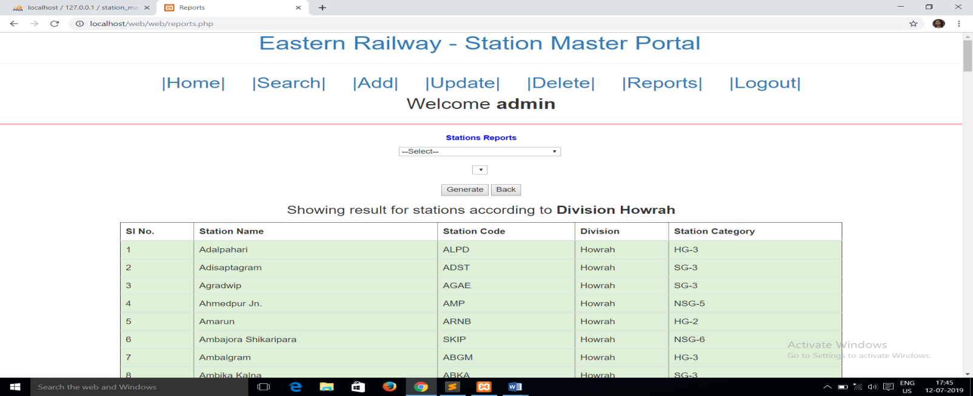

and so on…for 192 results

2. According to Category NSG-3:

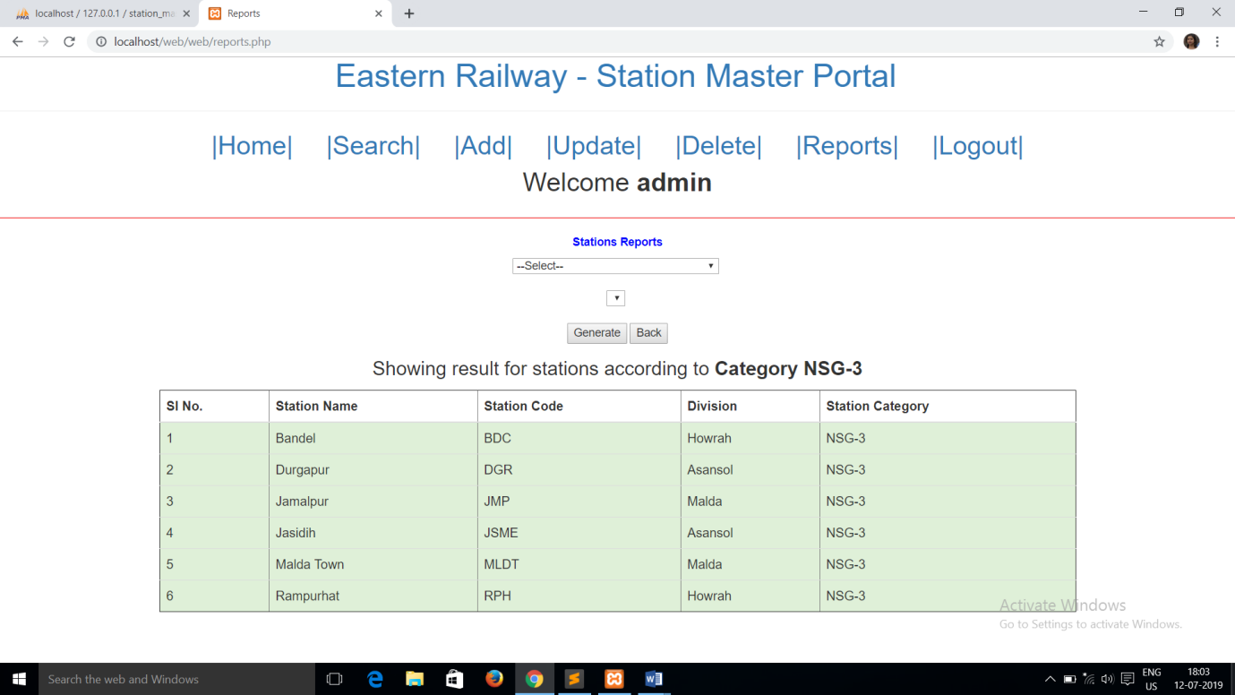

3. According to amenities Retiring Room (rr)

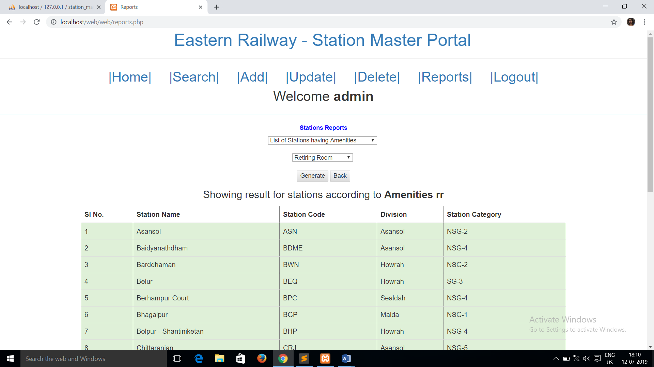

**CONCLUSION AND FUTURE SCOPE OF STUDY**

The goals and objectives set forward with respect to the ‘Eastern Railway – Station Master Portal’ were successfully implemented with the tools provided. The purpose of the Portal was to offer seamless operations over hundreds of records related to stations under Eastern Railway.

The designed web portal uses HTML, CSS and JavaScript for rendering its front end while back end development was done using PHP. The portal was secured using a login page, upon successful entry of which, a wide range of operations could be performed.

The Station Master portal equips features like search and addition of records, deletion of records, updating records with appropriate results and a report generation page that offers the option for quickly producing a hard copy of the obtained report through a print button.

Clearly evident from the list of photographs (pages 8-12) and results of reports (pages 25- 35), the web portal created runs bug-free, without undesirable errors and is quite simple and user-friendly to operate on. The additional functionality of session security and user verification makes the system more secure. The overall interface is minimalistic yet robust and serves the purpose of the desired project successfully.

The records are safely stored on a server machine, which in this case is our own PC, and is maintained and manipulated with the help of MySQL Database. All queries are written in SQL and are executed by MySQL Software. Apache is the server side software which handles the requests on the server side and communicates with the client computer.

Future prospects of the project can be listed as follows:

1. Enriched GUI with more interactive drop down menus and buttons.
2. More operations to expand the domain of the web portal beyond just the station master.
3. Making the portal mobile (and other portable platforms) compatible.

**REFERENCES**

### Websites:

1. <https://www.w3schools.com/php/>
2. <https://www.w3schools.com/sql/default.asp>
3. <https://www.w3schools.com/js/default.asp>
4. <https://www.tutorialspoint.com/php/>
5. <https://tutorial.techaltum.com/webdesigning.html>
6. [https://www.websitebuilderexpert.com/designing-websites/website-design- tutorials/](https://www.websitebuilderexpert.com/designing-websites/website-design-tutorials/)
7. <http://www.mysqltutorial.org/>
8. <https://www.phpknowhow.com/basics/working-with-xampp/>
9. <https://htmldog.com/guides/javascript/>
10. <https://www.csstutorial.net/>

### Books:

1. Programming PHP by Rasmus Lerdorf
2. Head First PHP and MySQL by Lynn Beighley & Michael Morrison

**APPENDICES**

The table ‘stations’ which has 582 records and 23 fields was shortened in some places throughout the project. For reference, all 23 fields and some records of the table are shown below:

